Experiment description file format

This document is a guide of the format description of the file that contains data of the prebuilt experiments for the "SquidStat" GUI.

Developers can use this guide to add new prebuilt experiments.

# General description

Every prebuilt experiment on the "Run an Experiment" tab is loaded dynamically based on the text files.

Those text files must:

* have the "*.json" extension;
* be placed at the "$(SquidStatRoot)\prebuilt\" directory;
* be written using JSON[1] syntax.

# Top-level fields description

The table 1 contains the fields description of the top-level JSON-object.

Table 1 – Top-level fields

|  |  |  |
| --- | --- | --- |
| Field name | Type | Description |
| short-name | String | The experiment name that will be displayed at the list on the left side of the "Run an Experiment" tab (see fig. 1). |
| name | String | The experiment name that will be displayed at the detailed description region (the center of the "Run an Experiment" tab, see fig. 2). |
| description | String | The experiment description will be displayed at the detailed description region (the center of the "Run an Experiment" tab, see fig. 2). |
| image-path | String | The relative path to the image file, that will be displayed at the detailed description region (the center of the "Run an Experiment" tab, see fig. 2). |
| nodes | Object | The object describes the ExperimentNode_t structures order, type and fields default values. For more details see p. 3. |

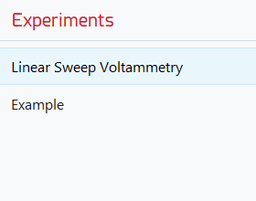

Figure 1 – List of the prebuilt experiments

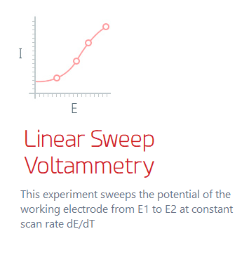

Figure 2 – Detailed experiment description

# Node object description

The table 2 contains the fields description of the node JSON-object.

Table 2 – Node object fields

| Field name | Type | Description |
| --- | --- | --- |
| repetition | Double | Represents the count of repetitions of the object that will be sent to the hardware.  Will be interpreted as integer. |
| type | String | Type of the object.  Allowed values: "set" and "node".  If type is "set" – the "elements" filed expected.  Otherwise – the "parameters" field expected. |
| elements | Array | Will be processed ONLY if type is "set".  Contains the array of the node JSON-object. |
| parameters | Object | Will be processed ONLY if type is "node".  Contains the type and optional default values of the ExperimentNode_t structure. For more details see table 3. |

The table 3 contains the fields description of the parameters of the node JSON‑object with type "node". All fields except the "nodeType" are optional.

NOTE: fields that correspond to the 64-bit value fields must be written as String-type JSON‑values.

Table 3 – Parameters object fields

| Field name | Type | Description |
| --- | --- | --- |
| nodeType | String | Represents the type of the ExperimentNode_t structure.  Semantically identical to the NodeType_t enumeration.  E.g.: to describe the node with the type NodeType_t::DCNODE_SWEEP need to set the "DCNODE_SWEEP" value. |
| DCNODE_SWEEP | | |
| VStart | Double | ExperimentNode_t::DCSweep.VStart |
| VEnd | Double | ExperimentNode_t::DCSweep.VEnd |
| dVdt | Double | ExperimentNode_t::DCSweep.dVdt |
| DCNODE_OCP | | |
|  |  |  |
|  |  |  |
|  |  |  |
| DCNODE_POINT | | |
|  |  |  |
|  |  |  |
|  |  |  |
| DCNODE_NORMALPULSE | | |
|  |  |  |
|  |  |  |
|  |  |  |
| … | | |
|  |  |  |
|  |  |  |
|  |  |  |

# File example

Below there is an example of the experiment text file content.

It describes the experiment that will totally run six nodes (the sequence of two nodes of the type "DCNODE_SWEEP" that will be repeated three times).

1. {
2. "short-name": "Linear Sweep Voltammetry",
3. "name": "Linear Sweep Voltammetry",
4. "description": "description",
5. "image-path": "./experiment.png",
6. "nodes": {
7. "repetition": 3,
8. "type": "set",
9. "elements": [
10. {
11. "repetition": 1,
12. "type": "node",
13. "parameters": {
14. "nodeType": "DCNODE_SWEEP",
15. "VStart": 0,
16. "VEnd": 1024,
17. "dVdt": 1
18. }
19. },
20. {
21. "repetition": 1,
22. "type": "node",
23. "parameters": {
24. "nodeType": "DCNODE_SWEEP",
25. "VStart": 1024,
26. "VEnd": 0,
27. "dVdt": -1
28. }
29. }
30. ]
31. }
32. }

1. JavaScript Object Notation (JSON) syntax description: https://goo.gl/s36B16